NAME:............................................................................................
END OF EDIFY PROGRAMME S.1 CHEMISTRY EXAM
TOPIC: USING MATERIALS
Instructions
1. Print or copy down the questions.
2. Answer the questions on plain/ ruled papers.
3. After answering, come back here on Google Classroom under the class work section where you downloaded the paper.
4. Click on the 'Add Work' button and use the scanner option to scan your work as a single PDF document with all pages included. Ensure that you adjust the crop in order to capture the full paper being scanned.
5. Turn in your work for marking as demonstrated in this video: https://youtu.be/lU3Ln28lucA
6. The deadline for submission is today at 9:00pm.
Activity of integration
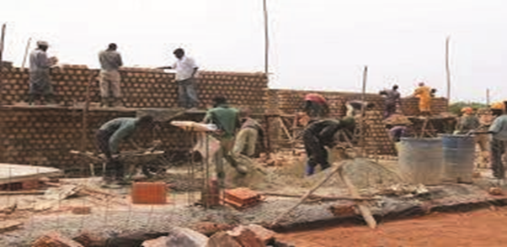
You have been given a contract to sensitise people in your hometown on how to select building materials for constructing a community school. They are expected to gather materials for the walls and the roof. Since there are many people in the community, they will need to deal with the waste materials.
Task.
Plan your sensitisation message for the community.
END

